SIMATS ENGINEERING
SAVEETHA INSTITUTE OF MEDICAL AND TECHNICAL SCIENCES
CHENNAI – 602105
Department of Computer Science and Engineering

ASSESSMENT TOOL 1 – CASE STUDY

Course Code: | DSA0502 | Course Title: | Query Processing for Data Science
CO Assessed: | CO4 | Assessment: | Tool 1– CASE STUDY
Weightage: |  | Total Marks:
CO4 Statement: Explore datasets using analytical techniques such as grouping, correlation detection, joining datasets, and extracting meaningful insights.
Student Name: | G Rajasekhar Reddy | Reg. No.: | 192424216
Section / Batch: | BTech-AI&DS | Date of Submission: | 13/08/2026
Faculty In-charge: | Dr. B.Shyamala Gowri | Project Mode: | Individual Submission

Code of Conduct
I G Rajasekhar Reddy(192424216) (Name / Reg No) certify that this submission is my original work and that I have adhered to all guidelines specified for this assessment. I understand that any violation of academic integrity rules will result in disciplinary action.
Signature: G Rajasekhar Reddy

Question 2 – Student Academic Performance Analysis
A college has Student, Attendance, Internal Marks, Assignment, and Examination datasets. Integrate the datasets and analyze student performance based on department, semester, attendance, and marks. Identify correlations and outliers and visualize performance trends. Provide 5 key findings and recommendations
Aim:
To develop a Python program using Pandas and Matplotlib to integrate and analyze Student, Attendance, Internal Marks, Assignment, and Examination datasets, identify performance patterns using grouping, segmentation, correlation and outlier detection, perform time-based analysis, visualize the results, and provide key findings and recommendations.
Program:
import pandas as pd
import numpy as np
import matplotlib.pyplot as plt
# --------------------------------------------------
# 1. DATA IMPORTING AND DATASET CREATION
# --------------------------------------------------
student = pd.DataFrame({
"Student_ID": [101, 102, 103, 104, 105, 106, 107, 108],
"Name": [
"Rahul", "Priya", "Arun", "Sneha",
"Kiran", "Anu", "Vijay", "Meena"
],
"Department": [
"CSE", "CSE", "ECE", "ECE",
"CSE", "ECE", "CSE", "ECE"
],
"Semester": [4, 4, 4, 4, 5, 5, 5, 5]
})
attendance = pd.DataFrame({
"Student_ID": [101, 102, 103, 104, 105, 106, 107, 108],
"Attendance": [92, 85, 78, 95, 88, 72, 98, 80]
})
internal = pd.DataFrame({
"Student_ID": [101, 102, 103, 104, 105, 106, 107, 108],
"Internal_Marks": [42, 38, 35, 45, 40, 30, 48, 36]
})
assignment = pd.DataFrame({
"Student_ID": [101, 102, 103, 104, 105, 106, 107, 108],
"Assignment_Marks": [18, 16, 15, 19, 17, 13, 20, 15]
})
examination = pd.DataFrame({
"Student_ID": [101, 102, 103, 104, 105, 106, 107, 108],
"Exam_Marks": [85, 78, 70, 92, 82, 65, 95, 74],
"Exam_Date": [
"2026-06-01",
"2026-06-01",
"2026-06-02",
"2026-06-02",
"2026-06-03",
"2026-06-03",
"2026-06-04",
"2026-06-04"
]
})
print("DATASET DESCRIPTION")
print("Student Dataset:", student.shape)
print("Attendance Dataset:", attendance.shape)
print("Internal Marks Dataset:", internal.shape)
print("Assignment Dataset:", assignment.shape)
print("Examination Dataset:", examination.shape)
# --------------------------------------------------
# 2. DATA EXPLORATION
# --------------------------------------------------
print("\nSTUDENT DATA")
print(student)
print("\nSTUDENT DATA INFORMATION")
print(student.info())
print("\nEXAMINATION STATISTICS")
print(examination.describe())
print("\nMISSING VALUES")
print(student.isnull().sum())
print(attendance.isnull().sum())
print(internal.isnull().sum())
print(assignment.isnull().sum())
print(examination.isnull().sum())
# --------------------------------------------------
# 3. JOINING MULTIPLE DATASETS
# --------------------------------------------------
data = pd.merge(
student,
attendance,
on="Student_ID"
)
data = pd.merge(
data,
internal,
on="Student_ID"
)
data = pd.merge(
data,
assignment,
on="Student_ID"
)
data = pd.merge(
data,
examination,
on="Student_ID"
)
print("\nINTEGRATED DATASET")
print(data)
# --------------------------------------------------
# 4. GROUPING AND AGGREGATION
# --------------------------------------------------
department_analysis = data.groupby(
"Department"
)[
["Attendance", "Internal_Marks",
"Assignment_Marks", "Exam_Marks"]
].mean()
print("\nAVERAGE PERFORMANCE BY DEPARTMENT")
print(department_analysis)
semester_analysis = data.groupby(
"Semester"
)["Exam_Marks"].mean()
print("\nAVERAGE EXAM MARKS BY SEMESTER")
print(semester_analysis)
# --------------------------------------------------
# 5. DATA SEGMENTATION
# --------------------------------------------------
def performance_category(mark):

if mark >= 85:
return "High"

elif mark >= 70:
return "Medium"

else:
return "Low"
data["Performance_Level"] = (
data["Exam_Marks"]
.apply(performance_category)
)
print("\nSTUDENT PERFORMANCE SEGMENTATION")
print(
data[
["Student_ID", "Name",
"Exam_Marks", "Performance_Level"]
]
)
print("\nPERFORMANCE GROUP COUNT")
print(data["Performance_Level"].value_counts())
# --------------------------------------------------
# 6. CORRELATION ANALYSIS
# --------------------------------------------------
correlation = data[
[
"Attendance",
"Internal_Marks",
"Assignment_Marks",
"Exam_Marks"
]
].corr()
print("\nCORRELATION MATRIX")
print(correlation)
# --------------------------------------------------
# 7. OUTLIER DETECTION USING IQR
# --------------------------------------------------
Q1 = data["Exam_Marks"].quantile(0.25)
Q3 = data["Exam_Marks"].quantile(0.75)
IQR = Q3 - Q1
lower_limit = Q1 - 1.5 * IQR
upper_limit = Q3 + 1.5 * IQR
outliers = data[
(data["Exam_Marks"] < lower_limit) |
(data["Exam_Marks"] > upper_limit)
]
print("\nOUTLIER DETECTION")
print("Q1:", Q1)
print("Q3:", Q3)
print("IQR:", IQR)
print("Lower Limit:", lower_limit)
print("Upper Limit:", upper_limit)
if len(outliers) == 0:
print("No exam mark outliers detected.")
else:
print("Outliers:")
print(outliers[
["Student_ID", "Name", "Exam_Marks"]
])

# --------------------------------------------------
# 8. TIME-BASED ANALYSIS
# --------------------------------------------------
data["Exam_Date"] = pd.to_datetime(
data["Exam_Date"]
)
time_analysis = data.groupby(
"Exam_Date"
)["Exam_Marks"].mean()

print("\nTIME-BASED PERFORMANCE ANALYSIS")
print(time_analysis)
# --------------------------------------------------
# 9. VISUALIZATION
# --------------------------------------------------
# Bar Chart - Department Performance
department_analysis["Exam_Marks"].plot(
kind="bar"
)
plt.title("Average Exam Marks by Department")
plt.xlabel("Department")
plt.ylabel("Average Exam Marks")
plt.tight_layout()
plt.show()

# Histogram - Exam Marks
plt.hist(
data["Exam_Marks"],
bins=5,
edgecolor="black"
)
plt.title("Distribution of Exam Marks")
plt.xlabel("Exam Marks")
plt.ylabel("Number of Students")
plt.tight_layout()
plt.show()
# Box Plot - Exam Marks
plt.boxplot(
data["Exam_Marks"]
)
plt.title("Exam Marks Outlier Detection")
plt.ylabel("Exam Marks")
plt.tight_layout()
plt.show()
# Scatter Plot - Attendance vs Exam Marks
plt.scatter(
data["Attendance"],
data["Exam_Marks"]
)
plt.title("Attendance vs Exam Marks")
plt.xlabel("Attendance (%)")
plt.ylabel("Exam Marks")
plt.tight_layout()
plt.show()
# Scatter Plot - Assignment vs Exam Marks
plt.scatter(
data["Assignment_Marks"],
data["Exam_Marks"]
)
plt.title("Assignment Marks vs Exam Marks")
plt.xlabel("Assignment Marks")
plt.ylabel("Exam Marks")
plt.tight_layout()
plt.show()
# Line Chart - Time-Based Analysis
plt.plot(
time_analysis.index,
time_analysis.values,
marker="o"
)
plt.title("Average Exam Performance Over Time")
plt.xlabel("Exam Date")
plt.ylabel("Average Exam Marks")
plt.xticks(rotation=45)
plt.tight_layout()
plt.show()
# Heatmap using Matplotlib
plt.imshow(
correlation,
cmap="coolwarm",
interpolation="nearest"
)
plt.colorbar()
plt.xticks(
range(len(correlation.columns)),
correlation.columns,
rotation=45
)
plt.yticks(
range(len(correlation.columns)),
correlation.columns
)
plt.title("Correlation Heatmap")
for i in range(len(correlation)):
for j in range(len(correlation)):
plt.text(
j,
i,
round(correlation.iloc[i, j], 2),
ha="center",
va="center"
)
plt.tight_layout()
plt.show()
# --------------------------------------------------
# 10. KEY FINDINGS AND RECOMMENDATIONS
# --------------------------------------------------
print("\nKEY FINDINGS")
highest_student = data.loc[
data["Exam_Marks"].idxmax()
]
lowest_student = data.loc[
data["Exam_Marks"].idxmin()
]
best_department = department_analysis[
"Exam_Marks"
].idxmax()
best_department_mark = department_analysis[
"Exam_Marks"
].max()
attendance_correlation = correlation.loc[
"Attendance",
"Exam_Marks"
]
assignment_correlation = correlation.loc[
"Assignment_Marks",
"Exam_Marks"
]
print(
"1. Highest performing student:",
highest_student["Name"],
"with",
highest_student["Exam_Marks"],
"marks."
)
print(
"2. Lowest performing student:",
lowest_student["Name"],
"with",
lowest_student["Exam_Marks"],
"marks."
)
print(
"3. Best performing department:",
best_department,
"with average exam marks of",
round(best_department_mark, 2)
)
print(
"4. Attendance and exam marks correlation:",
round(attendance_correlation, 2)
)
print(
"5. Assignment and exam marks correlation:",
round(assignment_correlation, 2)
)

print("\nRECOMMENDATIONS")
print(
"1. Students with lower attendance should be encouraged "
"to attend classes regularly."
)
print(
"2. Low-performing students should receive additional "
"academic support."
)
print(
"3. Regular assignment practice should be encouraged."
)
print(
"4. Departments should monitor student performance "
"using periodic assessments."
)
print(
"5. Students with consistently low marks should receive "
"individual mentoring."
)
Output:
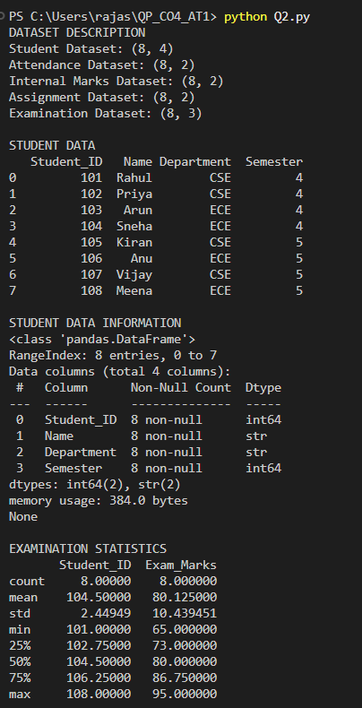
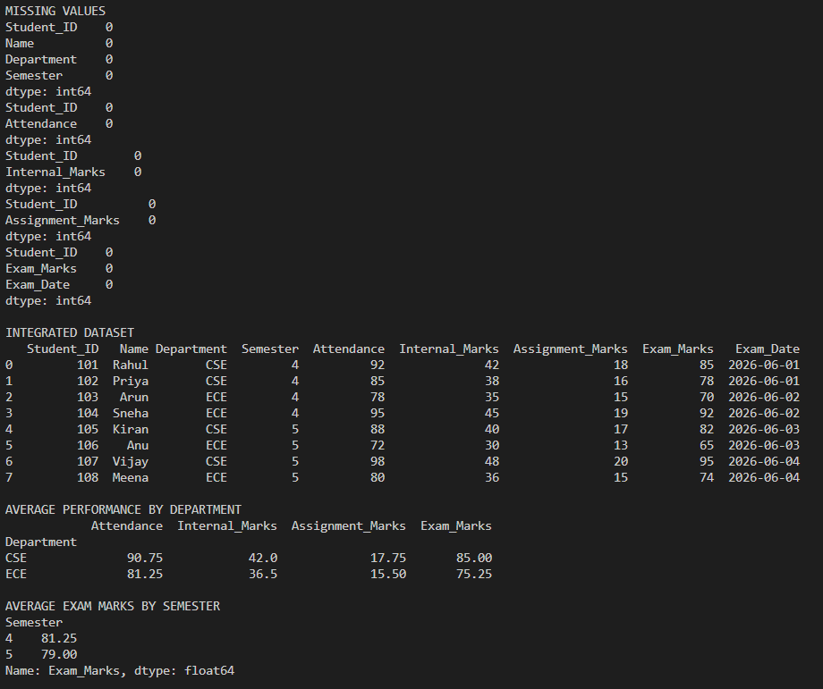
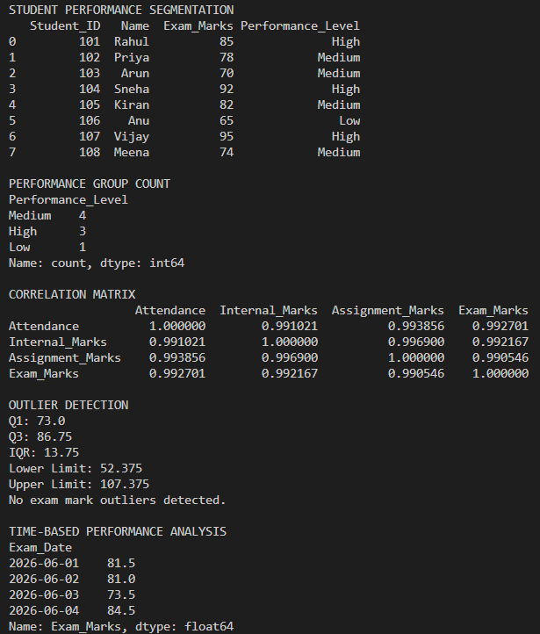
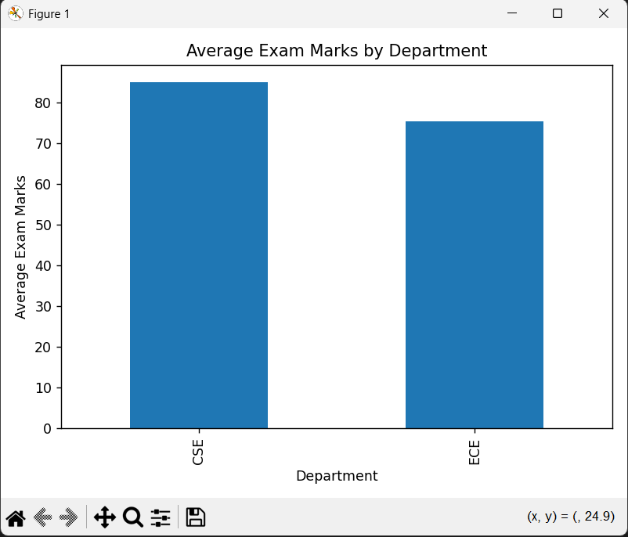

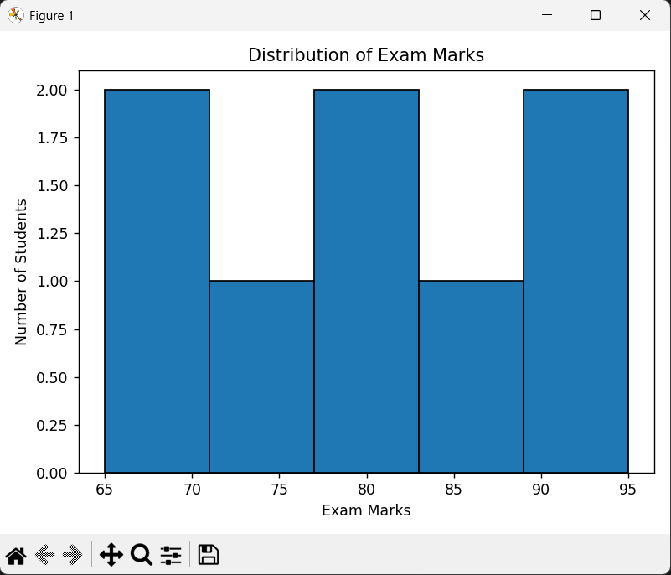
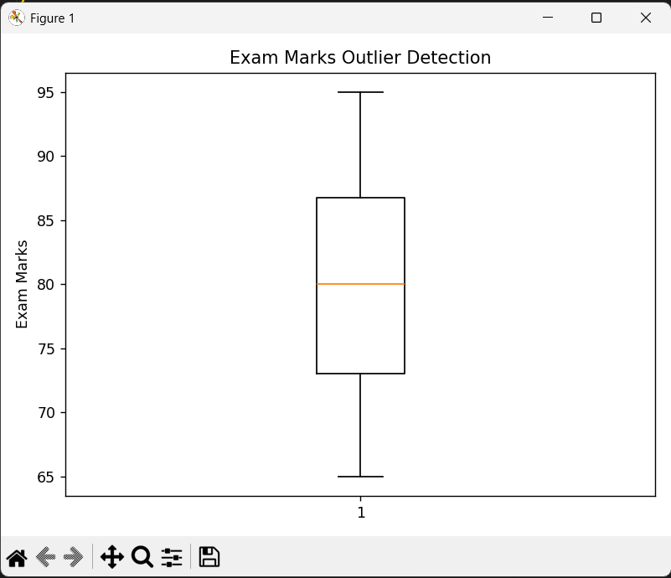
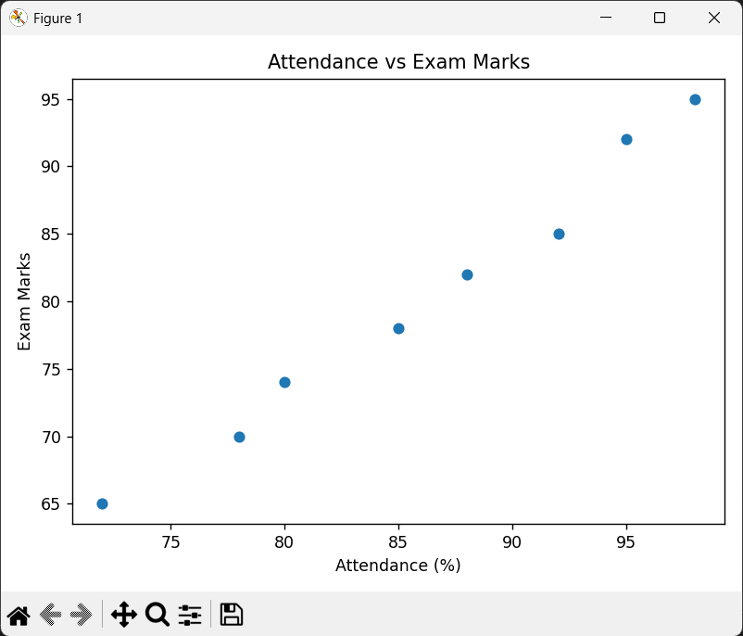

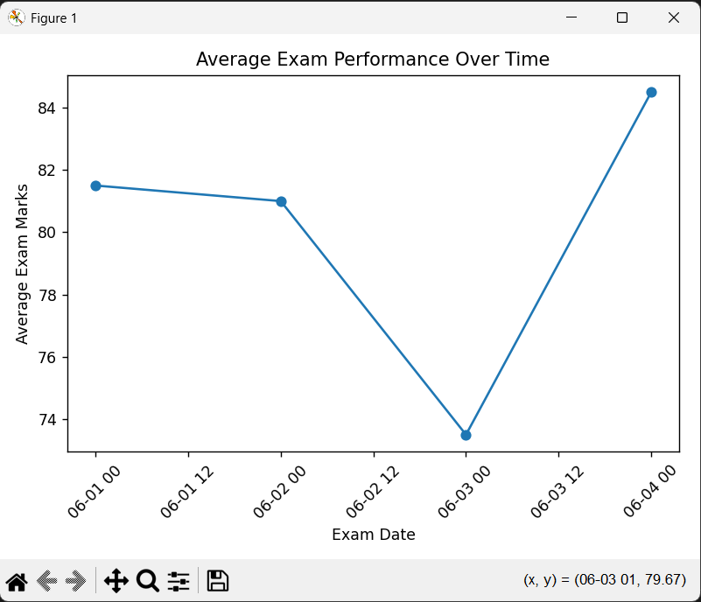

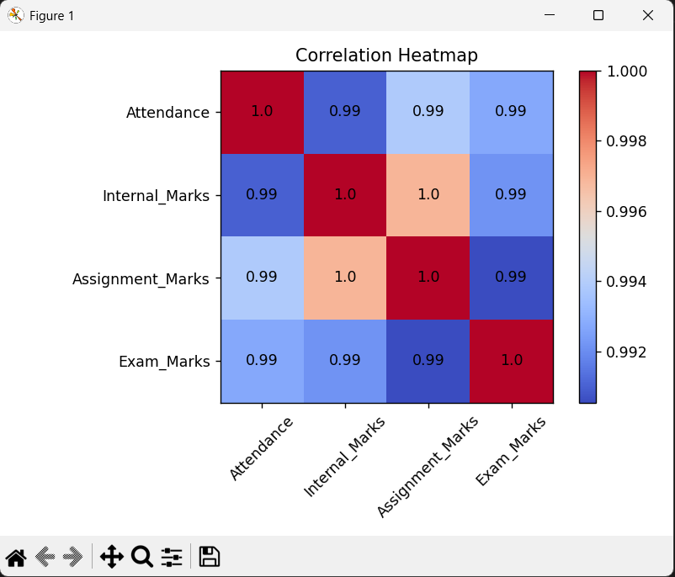

Question 4 – Employee Performance Analysis
An organization maintains Employee, Attendance, Salary, Department, and Performance datasets. Integrate the datasets and analyze employee performance based on attendance, salary, experience, department, and appraisal scores. Identify correlations and outliers and present the findings visually.
Aim:
To develop a Python program using Pandas and Matplotlib to integrate and analyze Employee, Attendance, Salary, Department, and Performance datasets, identify employee performance patterns using grouping, segmentation, correlation and outlier detection, perform time-based analysis, visualize the results, and provide key findings and recommendations.
Program:
import pandas as pd
import numpy as np
import matplotlib.pyplot as plt
# --------------------------------------------------
# 1. DATA IMPORTING AND DATASET CREATION
# --------------------------------------------------
employee = pd.DataFrame({
"Employee_ID": [101, 102, 103, 104, 105, 106, 107, 108],
"Employee_Name": [
"Rahul", "Priya", "Arun", "Sneha",
"Kiran", "Anu", "Vijay", "Meena"
],
"Department": [
"IT", "HR", "IT", "Finance",
"HR", "Finance", "IT", "HR"
],
"Experience": [2, 4, 3, 6, 5, 2, 7, 4]
})
attendance = pd.DataFrame({
"Employee_ID": [101, 102, 103, 104, 105, 106, 107, 108],
"Attendance": [92, 88, 85, 95, 90, 78, 98, 84]
})
salary = pd.DataFrame({
"Employee_ID": [101, 102, 103, 104, 105, 106, 107, 108],
"Salary": [45000, 52000, 48000, 70000,
60000, 40000, 85000, 55000]
})
department = pd.DataFrame({
"Employee_ID": [101, 102, 103, 104, 105, 106, 107, 108],
"Department_Code": [
"IT", "HR", "IT", "FIN",
"HR", "FIN", "IT", "HR"
]
})
performance = pd.DataFrame({
"Employee_ID": [101, 102, 103, 104, 105, 106, 107, 108],
"Appraisal_Score": [82, 76, 79, 91, 85, 68, 95, 74],
"Appraisal_Date": [
"2026-01-10",
"2026-01-12",
"2026-01-14",
"2026-01-16",
"2026-01-18",
"2026-01-20",
"2026-01-22",
"2026-01-24"
]
})
print("DATASET DESCRIPTION")
print("Employee Dataset:", employee.shape)
print("Attendance Dataset:", attendance.shape)
print("Salary Dataset:", salary.shape)
print("Department Dataset:", department.shape)
print("Performance Dataset:", performance.shape)
# --------------------------------------------------
# 2. DATA EXPLORATION
# --------------------------------------------------
print("\nEMPLOYEE DATA")
print(employee)
print("\nEMPLOYEE DATA INFORMATION")
print(employee.info())
print("\nPERFORMANCE STATISTICS")
print(performance.describe())
print("\nMISSING VALUES")
print(employee.isnull().sum())
print(attendance.isnull().sum())
print(salary.isnull().sum())
print(department.isnull().sum())
print(performance.isnull().sum())
# --------------------------------------------------
# 3. JOINING MULTIPLE DATASETS
# --------------------------------------------------
data = pd.merge(
employee,
attendance,
on="Employee_ID"
)
data = pd.merge(
data,
salary,
on="Employee_ID"
)
data = pd.merge(
data,
department,
on="Employee_ID"
)
data = pd.merge(
data,
performance,
on="Employee_ID"
)
print("\nINTEGRATED EMPLOYEE DATASET")
print(data)
# --------------------------------------------------
# 4. GROUPING AND AGGREGATION
# --------------------------------------------------
department_analysis = data.groupby(
"Department"
)[
["Attendance", "Salary",
"Experience", "Appraisal_Score"]
].mean()

print("\nAVERAGE PERFORMANCE BY DEPARTMENT")
print(department_analysis)
# --------------------------------------------------
# 5. DATA SEGMENTATION
# --------------------------------------------------
def performance_category(score):
if score >= 85:
return "High"
elif score >= 70:
return "Medium"
else:
return "Low"
data["Performance_Level"] = (
data["Appraisal_Score"]
.apply(performance_category)
)
print("\nEMPLOYEE PERFORMANCE SEGMENTATION")
print(
data[
[
"Employee_ID",
"Employee_Name",
"Appraisal_Score",
"Performance_Level"
]
]
)
print("\nPERFORMANCE GROUP COUNT")
print(
data["Performance_Level"].value_counts()
)
# --------------------------------------------------
# 6. CORRELATION ANALYSIS
# --------------------------------------------------
correlation = data[
[
"Attendance",
"Salary",
"Experience",
"Appraisal_Score"
]
].corr()
print("\nCORRELATION MATRIX")
print(correlation)
# --------------------------------------------------
# 7. OUTLIER DETECTION USING IQR
# --------------------------------------------------
Q1 = data["Salary"].quantile(0.25)
Q3 = data["Salary"].quantile(0.75)
IQR = Q3 - Q1
lower_limit = Q1 - 1.5 * IQR
upper_limit = Q3 + 1.5 * IQR
salary_outliers = data[
(data["Salary"] < lower_limit) |
(data["Salary"] > upper_limit)
]
print("\nSALARY OUTLIER DETECTION")
print("Q1:", Q1)
print("Q3:", Q3)
print("IQR:", IQR)
print("Lower Limit:", lower_limit)
print("Upper Limit:", upper_limit)
if len(salary_outliers) == 0:
print("No salary outliers detected.")
else:
print("Salary Outliers:")
print(
salary_outliers[
[
"Employee_ID",
"Employee_Name",
"Salary"
]
]
)
# --------------------------------------------------
# 8. TIME-BASED ANALYSIS
# --------------------------------------------------
data["Appraisal_Date"] = pd.to_datetime(
data["Appraisal_Date"]
)
time_analysis = data.groupby(
"Appraisal_Date"
)["Appraisal_Score"].mean()
print("\nTIME-BASED PERFORMANCE ANALYSIS")
print(time_analysis)
# --------------------------------------------------
# 9. VISUALIZATION
# --------------------------------------------------
# Bar Chart - Department Performance
department_analysis[
"Appraisal_Score"
].plot(
kind="bar"
)
plt.title("Average Appraisal Score by Department")
plt.xlabel("Department")
plt.ylabel("Average Appraisal Score")
plt.tight_layout()
plt.show()
# Histogram - Appraisal Scores
plt.hist(
data["Appraisal_Score"],
bins=5,
edgecolor="black"
)
plt.title("Distribution of Appraisal Scores")
plt.xlabel("Appraisal Score")
plt.ylabel("Number of Employees")
plt.tight_layout()
plt.show()
# Box Plot - Salary
plt.boxplot(
data["Salary"]
)
plt.title("Salary Outlier Detection")
plt.ylabel("Salary")
plt.tight_layout()
plt.show()
# Scatter Plot - Attendance vs Performance
plt.scatter(
data["Attendance"],
data["Appraisal_Score"]
)
plt.title("Attendance vs Appraisal Score")
plt.xlabel("Attendance (%)")
plt.ylabel("Appraisal Score")
plt.tight_layout()
plt.show()
# Scatter Plot - Experience vs Performance
plt.scatter(
data["Experience"],
data["Appraisal_Score"]
)
plt.title("Experience vs Appraisal Score")
plt.xlabel("Experience (Years)")
plt.ylabel("Appraisal Score")
plt.tight_layout()
plt.show()
# Line Chart - Time-Based Analysis
plt.plot(
time_analysis.index,
time_analysis.values,
marker="o"
)
plt.title("Appraisal Performance Over Time")
plt.xlabel("Appraisal Date")
plt.ylabel("Average Appraisal Score")
plt.xticks(rotation=45)
plt.tight_layout()
plt.show()
# Correlation Heatmap
plt.imshow(
correlation,
cmap="coolwarm",
interpolation="nearest"
)
plt.colorbar()
plt.xticks(
range(len(correlation.columns)),
correlation.columns,
rotation=45
)
plt.yticks(
range(len(correlation.columns)),
correlation.columns
)
plt.title("Employee Performance Correlation")
for i in range(len(correlation)):
for j in range(len(correlation)):
plt.text(
j,
i,
round(correlation.iloc[i, j], 2),
ha="center",
va="center"
)
plt.tight_layout()
plt.show()
# --------------------------------------------------
# 10. KEY FINDINGS AND RECOMMENDATIONS
# --------------------------------------------------
print("\nKEY FINDINGS")
highest_employee = data.loc[
data["Appraisal_Score"].idxmax()
]
lowest_employee = data.loc[
data["Appraisal_Score"].idxmin()
]
best_department = department_analysis[
"Appraisal_Score"
].idxmax()
best_department_score = department_analysis[
"Appraisal_Score"
].max()
attendance_correlation = correlation.loc[
"Attendance",
"Appraisal_Score"
]
experience_correlation = correlation.loc[
"Experience",
"Appraisal_Score"
]
print(
"1. Highest performing employee:",
highest_employee["Employee_Name"],
"with appraisal score",
highest_employee["Appraisal_Score"]
)
print(
"2. Lowest performing employee:",
lowest_employee["Employee_Name"],
"with appraisal score",
lowest_employee["Appraisal_Score"]
)
print(
"3. Best performing department:",
best_department,
"with average appraisal score",
round(best_department_score, 2)
)
print(
"4. Attendance and appraisal score correlation:",
round(attendance_correlation, 2)
)
print(
"5. Experience and appraisal score correlation:",
round(experience_correlation, 2)
)
print("\nRECOMMENDATIONS")
print(
"1. Employees with low attendance should be encouraged "
"to maintain regular attendance."
)
print(
"2. Low-performing employees should receive additional "
"training and mentoring."
)
print(
"3. Organizations should recognize and reward "
"high-performing employees."
)
print(
"4. Employee performance should be reviewed periodically "
"using appraisal scores."
)
print(
"5. Departments should analyze attendance, experience "
"and salary along with performance."
)
Output:
